RESOLUTION NO.__________

RE: CERTIFICATE OF APPROPRIATENESS UNDER THE
PROVISIONS OF THE ACT OF THE PENNSYLVANIA
LEGISLATURE 1961, JUNE 13, P.L. 282 (53
SECTION 8004) AND BETHLEHEM ORDINANCE NO.
3952 AS AMENDED.

WHEREAS, it is proposed to install stairs from the platform to the parking lot at 55 W. Lehigh St. (The Freight House)

NOW, THEREFORE, BE IT RESOLVED by the Council of the City of Bethlehem that a Certificate of Appropriateness is hereby granted for the proposal.

Sponsored by: (s)

(s)

ADOPTED BY COUNCIL THIS DAY OF

(s)
President of Council

ATTEST:

(s)
City Clerk

HISTORICAL & ARCHITECTURAL REVIEW BOARD

The applicant requests approval for wooden steps and rails from the platform to the parking lot at 55 W. Lehigh St. (The Freight House)
APPLICATION #3:

G & GR Group
61 W. Lehigh St.
Bethlehem, PA 18018

OWNER:

__________________________________________________________________________

The Board upon motion by Phil Roeder and seconded by Marsha Fritz adopted the proposal that City Council issue a Certificate of Appropriateness for the following:

- New stairs are to comply with the city code.

2. Open risers are to be closed.

3. Rails are to be 42” guardrail and a 36” high handrails with the required
extensions.

4. The rails should be powder coated metal in the same color green as existing.

5. Existing stone steps at the west end of the building are to have guardrails and
handrails installed that match the north side existing stairs.

6. The motion was unanimously approved.

__________________________________________________________________________

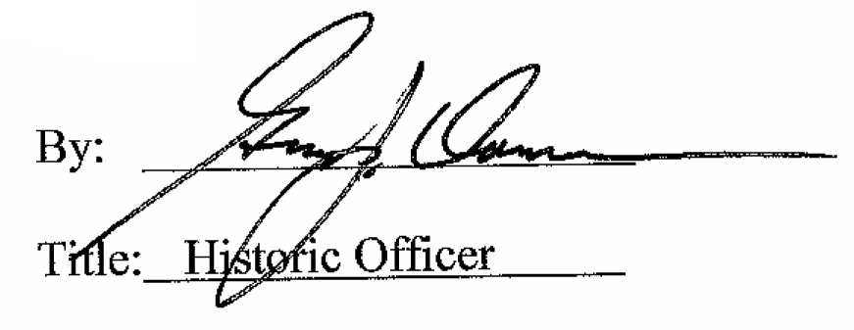

Date of Meeting: June 1, 2016

